**“Tutorial Website”**

**A Minor Project Report**

**Submitted in Partial Fulfillment of requirements for the Award of Degree of Bachelor of Engineering in Computer Science & Engineering**

**Submitted to**



**RAJIV GANDHI PROUDYOGIKI VISHWAVIDYALAYA, BHOPAL (M.P)**

**Submitted By**

(Ritvik Bandewar)

(0132CS171076)

**Under the guidance of**

**Prof. KANCHAN PANDEY As per Allotted by College**

**Radharaman Institute of Technology and Science**

Radharaman Logo

**DEPARTMENT OF COMPUTER SCIENCE & ENGINEERING**

**RADHA RAMAN INSTITUTE OF TECHNOLOGY & SCIENCE, BHOPAL (M.P.)**

**Session: July2019**

**RADHARAMAN INSTITUTE OF TECHNOLOGY & SCIENCE BHOPAL (M.P.)**

**Department of Computer Science & Engineering**

Description: Radharaman Logo

**APPROVAL CERTIFICATE**

This Minor project work entitled **“TUTORIAL WEBSITE”** being submitted by **“Ritvik Bandewar” (Roll No.:0132CS171076)** is/are approved for the award of degree of **Bachelor of Engineering** in **Computer Science and Engineering**.

**Internal Examiner** **External Examiner**

**Date: Date:**

**RADHARAMAN INSTITUTE OF TECHNOLOGY & SCIENCE BHOPAL (M.P.)**

**Department of Computer Science & Engineering**

**CANDIDATE DECLARATION**

We/I **“Ritvik Bandewar” (Roll No.:0132CS171076)** students of **Bachelor of Engineering** in **Computer Science & Engineering, Radharaman Institute Of Technology & Science**, **Bhopal (M.P.),** hereby declare that the work presented in this Minor project “**TUTORIAL WEBSITE**” is the outcome of our own work, is bonafide and correct to the best of our knowledge and this work has been carried out taking care of Engineering Ethics. The work presented does not infringe any patented work and has not been submitted to any other university or anywhere else for the award of any degree or any professional diploma.

**Date:**

**“Ritvik Bandewar” (0132CS171076)**

**ACKNOWLEDGEMENT**

This project work is the result of guidance and support of various people at RITS without whom all our effort would have been directionless and fruitless. We sincerely thank all of them, for assisting us in completing the dissertation.

We express our ardent and earnest gratitude to our guide, **Prof. Kanchan Pandey**, Department of Computer Science & Engineering, RITS Bhopal and **Prof. Chetan Agrawal**, HOD, Department of Computer Science & Engineering, RITS Bhopal for their help and encouragement at all the stages of our Work. Their guidance and motivation helped us to be fruitful in our effort.

We also express my heartfelt and profound gratitude to our Director **Dr. R. K. Pandey** for his valuable suggestion and ample resources at all stages of the research work.

Finally, we would like to say that we are indebted to my parents for everything that they have done for us. All of this would have been impossible without their constant support. And we also thank to God for being kind to me and driving me through this journey.

**“Ritvik Bandewar” (0132CS171076)**

**INDEX**

**Chapter 1 Introduction**

* Overview
* Problem Statement
* Objective
* Applications

**Chapter 2 Designing & Methodology**

* Overview of methodology
* Detail methods
* Diagrams (Flow Charts: Use Case, with explanation)
* E-R Diagrams

**Chapter 3 Implementation and Results**

* Screen Shots with Description
* Advantages of project

**Chapter 4 Conclusion & Future Scope**

* Conclusion
* Future Scope

**Chapter 1**

**INTRODUCTION**

1. **OVERVIEW:-**

In the internet many types of tutorial websites are available for Software & web development like – w3shcools.com, javatpoint, Geeksforgeeks,tutorialspoint etc. So working of these kind of website, my tutorial website work which called as “DEVELOPMENT WORLD”is also works , e.g. If any user want’s to learn any programming or markup language like C/C++ or HTML/CSS or JAVA,PYTHON etc. then simply he/she can gets many types of courses/content for learning with theory & with example of codes or syntex’s and with also online text editor’s compiler and video lectures also.

1.2 **PROBLEM STATEMENT:-**

When user search website’s for learning programm -ing so he/she have many op- tions but still he/she not satishfy because some unwanted reasons like in some

website’s theories are available in good manner but example of code are not desirable and understandable so in such type of case user have to use different – different sources , so these type of problem’s of user are solved by using my website “DEVELOPMENT WORLD”.

**1.3 OBJECTIVE:-**

The main objective of my project is to provide desirable content in understand- able language in a single plateform. Well-organized content, user-friendly site, effective calls to action , increase conversion rate. Objectives: Providing quality content on your  website , regularly adding new information , establishing trust.

**1.4 APPLICATION:-**

I used “SUBLINE TEXT EDITOR” for developing my project and for perform-

ing, I used chrome browser ..

**Chapter 2**

**Designing & Methodology**

* 1. **Overview of methodology:-**

Firstly user have to create his/her account then user can use my website and can get the courses of desirable language which he/she want’s to learn.

* 1. **Detail methods:-**

Firstly user’s have to visit my website and if user is new-visitor then he/she have to create own account by clicking on signin button which will be present on top-right of front page then after that user will be able to access courses so after this user have to click on the large text which will be shown in middle on front page and after that next page will open and then infront of user of horizontal list of some major languages like – HTML/CSS , C/C++ , JAVA , PYTHON etc.then user can select any language which he/she want’s to learn ,for example , if user want’s to learn HTML then user will click on HTML icon and then next page will open which contain all topic’s of HTML etc.

* 1. **FLOW-CHART:-**

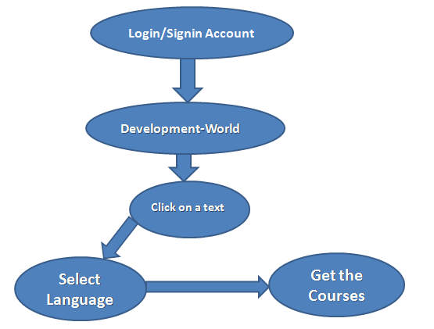

* 1. **ER-DIAGRAM:-**

**VISIT**

**COURSES**

**LANGUAGES**

=1

1=

0=

**SIGNIN**

**TEXT**

**LOGIN**

**Chapter 3**

**Implementation and Results**

* 1. **Screen Shots with Description:-**
* First page view of my website-

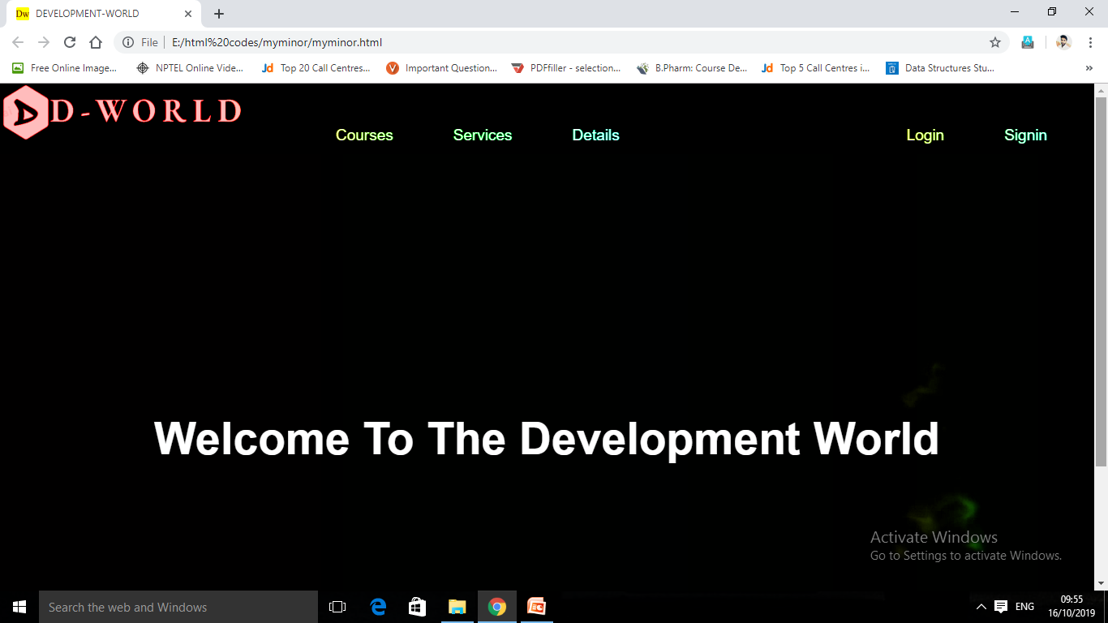

* Login page-

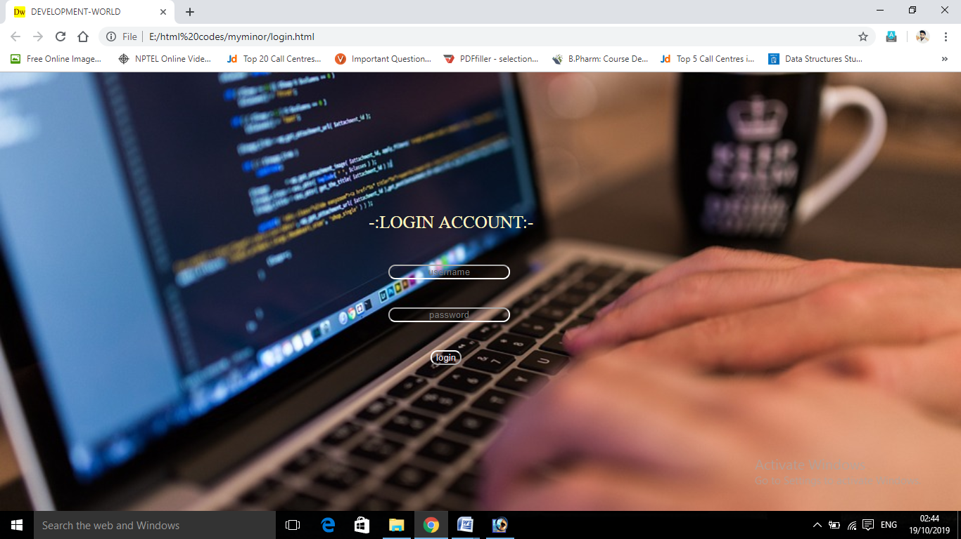

* Sign-in page

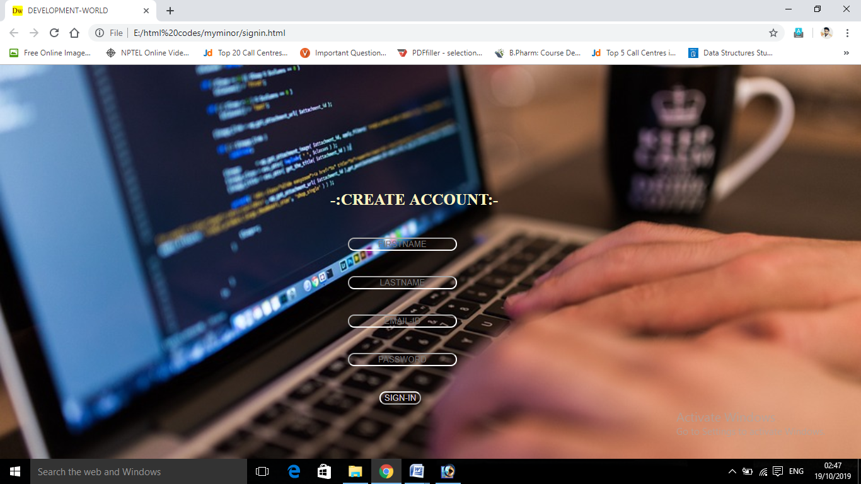

* Languages page

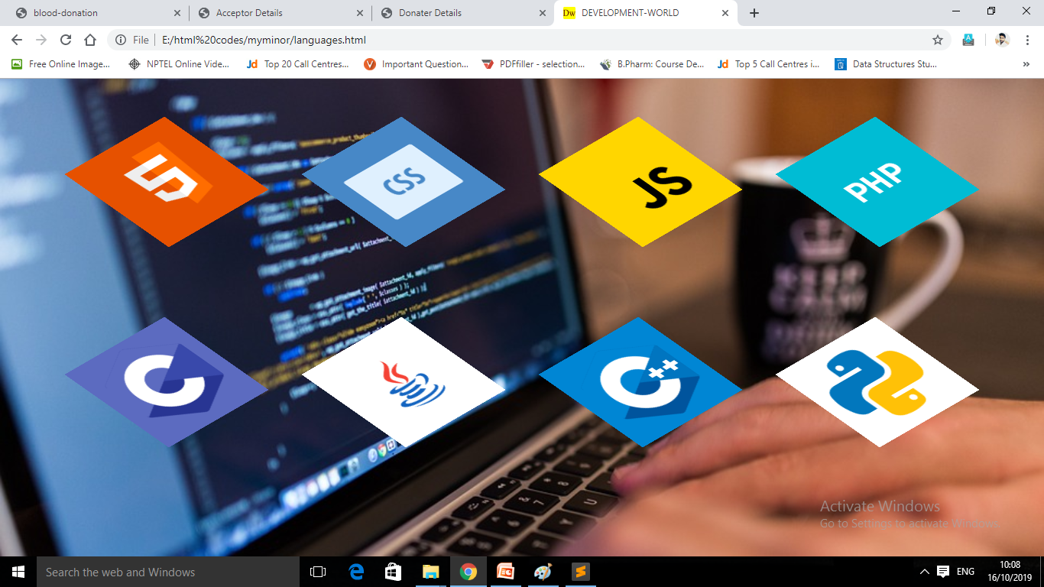

* For example user select HTML to learn then view will be

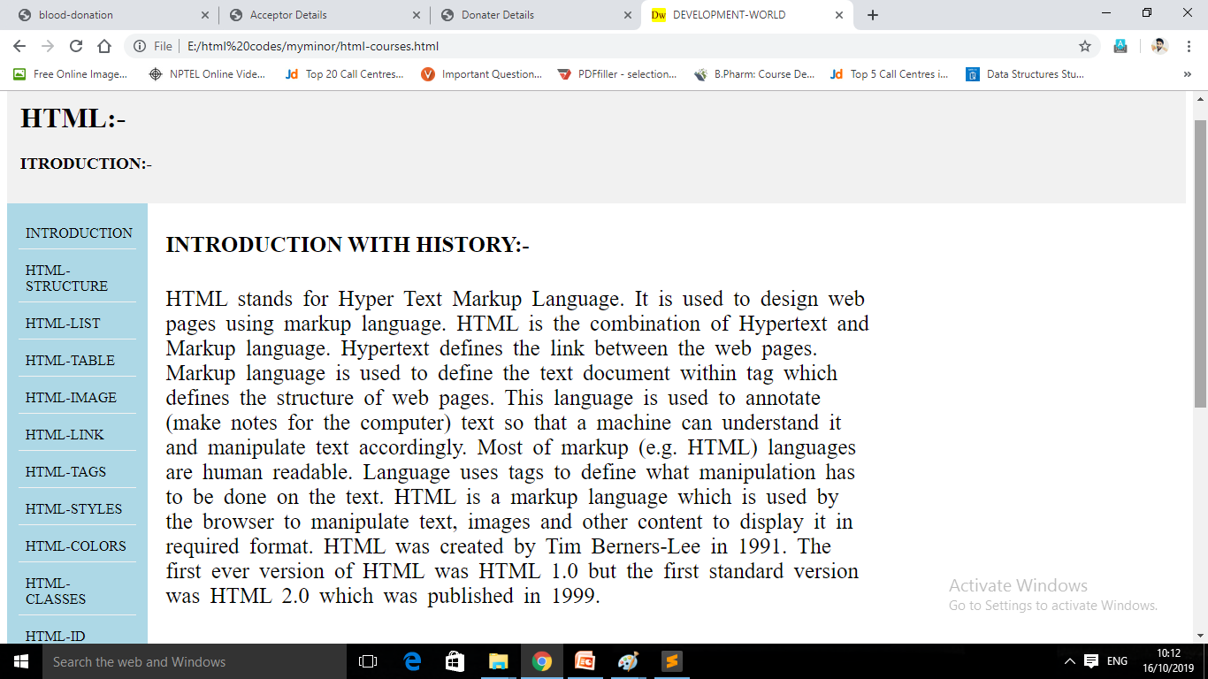

* If user select C-language to learn then view will be

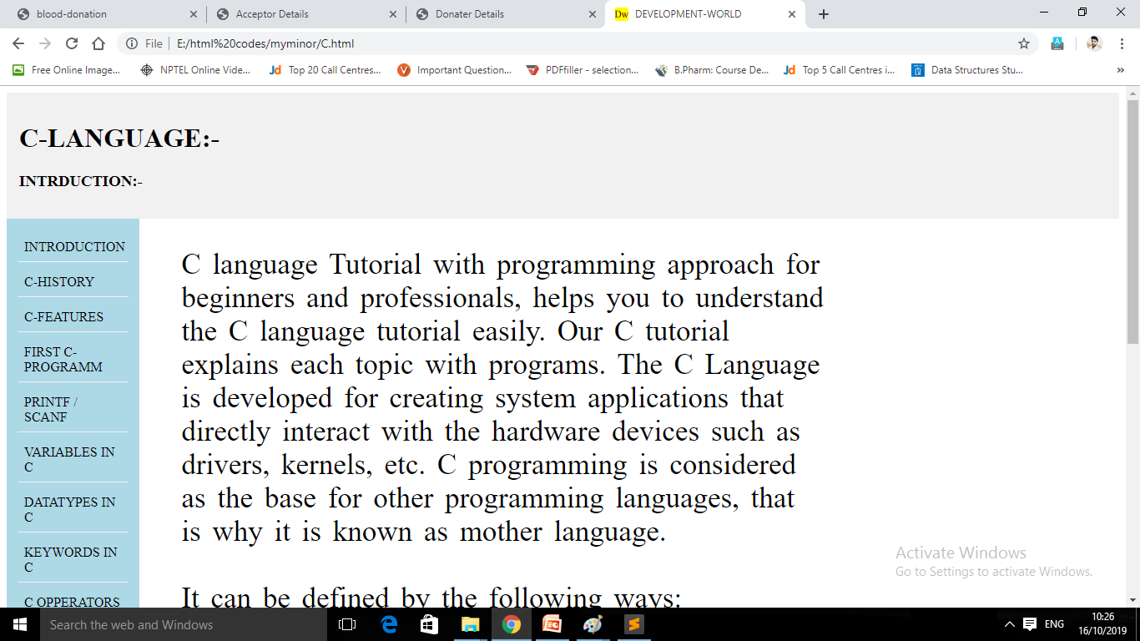

* Main HTML structure of web page

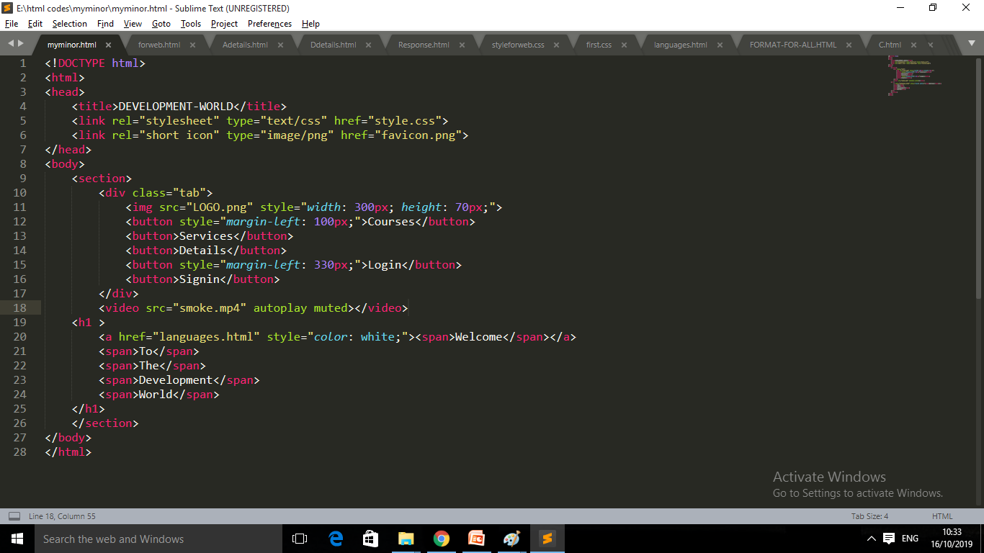

* 1. **Advantages of project:-**

a). Complete theory with example of code.

b). Well-organized content, user - friendly site.

c). All courses are freely available.

d). Video lectures of all topic’s are also available.

e). Online text editor &compiler’s are also will be

available.

f). Many things are present in a single plateform

that’swhy it saves user searching time .

**Chapter 4**

**Conclusion & Future Scope**

**4.1 Conclusion:-**

The conclusion of whole my project is , the information of all courses for

development which will be providing in my website ,should be appropriate

and should be present in easy manner for learning and all facilities , for

which user choose different-different option’s ,so these all facilities should

be provided in a single plateform , which saves the time of user and helpful

for user.

**4.2 Future Scope:-**

In future , I will add database with my website which helps to store the user

account details and helps in saving history of user search’s and we will convert

it into dynamic website which will be very attractive and more workable with

more features and regularly we updates It which causes user will also updated

and we will try to add all programming languages courses with example of codes

and with their online compiler’s .etc.

* 1. **Data Dictionary:-**

A data dictionary is a file or a set of files that includes a database's metadata. The data dictionary hold records about other objects in the database, such as data ownership, data relationships to other objects , and other data. The data dictionary is an essential component of any relational database. Ironically , because of its importance , it is invisible to most database users. Typically, only database administrators interact with the data dictionary.

The data dictionary, in general, includes information about the following:-

* Name of the data item.
* Aliases.
* Description/purpose.
* Related data items.
* Range of values.
* Data structure definition/Forms.

**Gantt chart:-**

|  |  |  |  |  |  |  |  |  |
| --- | --- | --- | --- | --- | --- | --- | --- | --- |
| **Weeks** | **1** | **2** | **3** | **4** | **5** | **6** | **7** | **8** |
|  |  |  |  |  |  |  |  |  |
|  |  |  |  |  |  |  |  |  |
| **Planning** |  |  |  |  |  |  |  |  |
|  |  |  |  |  |  |  |  |  |
| **Design** |  |  |  |  |  |  |  |  |
|  |  |  |  |  |  |  |  |  |
| **Coding** |  |  |  |  |  |  |  |  |
|  |  |  |  |  |  |  |  |  |
| **Testing** |  |  |  |  |  |  |  |  |
|  |  |  |  |  |  |  |  |  |
| **Delivery** |  |  |  |  |  |  |  |  |